cnPilot r201P
Cloud managed 802.11ac Dual Band Home Wi-Fi router with ATA voice and PoE out.
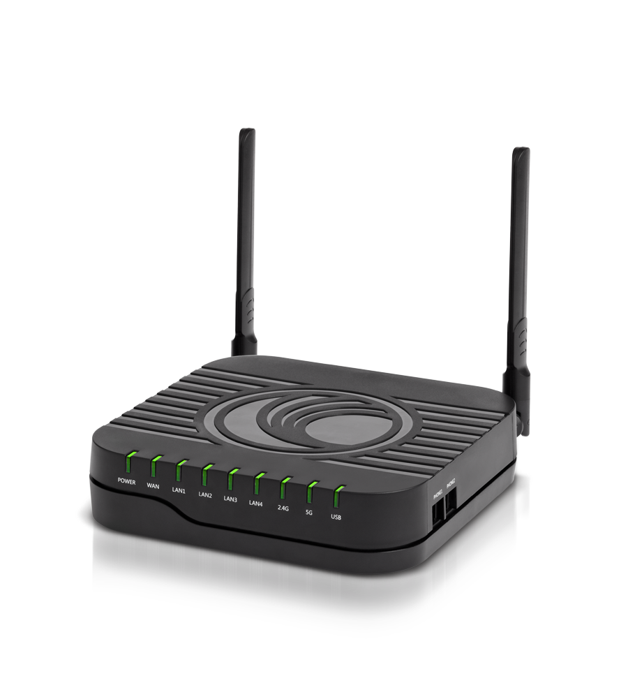

CNPILOT R201P

